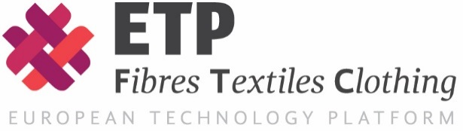
The European Technology Platform for
the Future of Textiles and Clothing a.i.s.b.l.
www.textile-platform.eu

Membership Subscription Form 2022

I, the undersigned, hereby apply for the following membership in the European Technology Platform for the Future of Textiles and Clothing.

Subscription type/cost | Please tick to mark your choice
Associate Membership / € 300.00 p.a.
Networking membership / € 100.00 p.a.
Observer (individual expert) / Free

Identification & contact details for further follow up
Legal name of organisation:………………………………
Place & country of establishment: ……………………….
Contact person (full name):……..………………………..
Function:………………….
E-mail:………………..
Address details for invoicing:
………………………………………
………………………………………
………………………………………

Please return this form to: Lutz Walter, Secretary General of the Textile ETP, e-mail: info@textile-platform.eu

