Race to the $5 Big Blind-Episode 43

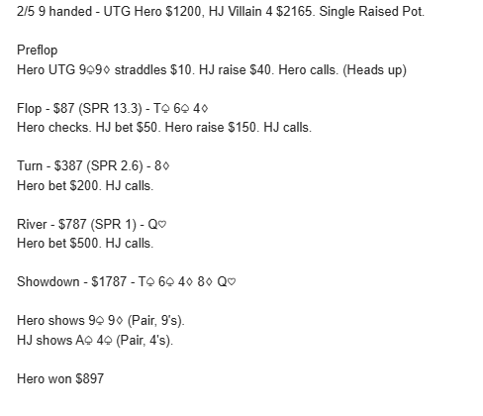

2/5 9 handed - UTG Hero $1450, HJ Villain 4 $2800, CO Villain 5 $1800. Single Raised Pot.

Preflop
Hero UTG 6♤6♡ straddles $10. HJ raise $40. CO calls. Hero calls. (3 players)

Flop - $127 (SPR 11.1) - J♢ T♧ T♡
Hero checks. HJ checks. CO checks.

Turn - $127 (SPR 11.1) - 6♧
Hero bet $75. HJ calls. CO folds.

River - $277 (SPR 4.8) - K♡
Hero bet $150. HJ calls.

Showdown - $577 - J♢ T♧ T♡ 6♧ K♡

Hero shows 6♤ 6♡ (Full House, 6's over 10's).
HJ shows K♢ Q♤ (Two Pair, K's & 10's).

Hero won $312

