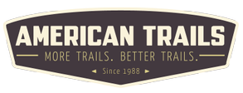

Legacy Trail Grant Program Application
Opens: October 2022, Deadline: December 15, 2022

Organization / Non-Federal Agency Information

Name of Organization / Non-Federal Agency

Contact Person

First Name Last Name

Contact Phone

Please enter a valid phone number.

Contact Email

example@example.com

Organization / Agency Website

Organization / Agency Address

EIN

For lead Non-profit organizations. If you are an agency, upload a letter of support from your agency leadership in the last section of this application.

Project Location Information

USFS Region *
See diagram below for FS Regions. Enter Region number only.

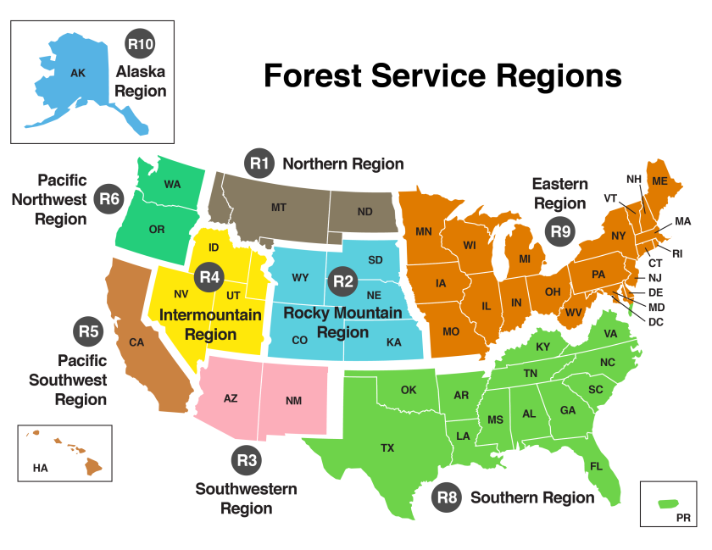

Forest / Grassland *

Name of Forest or Grassland where project is located.

Forest Service Coordination *

Describe coordination with the local Ranger District and/or Forest around the planning and implementation of this project. (In the last section of the application you must upload a letter of support from local Forest Service Ranger District or Forest Supervisor for this project. A letter from the District Ranger is preferred.)

Trail Name(s) and Special Area(s) Supported

Designed Use of Project
ATV/UTV
Singletrack motorcycle Snowmobile
High Clearance Vehicles (Jeep) Hike/Pedestrian
Bicycle Equestrian Ski/Dogsled Wilderness

Volunteer, Staff, and Corps Information

Volunteers

The number of volunteers anticipated to be engaged throughout this project.

Volunteer Hours

The total number of hours of volunteer labor anticipated throughout this project.

Staff/Crew

The number of staff or paid crew that will support this project.

Staff/Crew Hours

The total number of hours of staff or paid crew hours that will support this project.

Civilian Conservation Corps Members

The number of Civilian Conservation or Youth Corps members supporting this project.

Civilian Conservation Corps Hours

The total number of corps crew hours that will support this project.

Proposal / Project Information

Project Eligible Activities (must meet Legacy Roads and Trails Eligibility) *
Restore passages for fish and other aquatic species by improving, repairing, or replacing culverts and other infrastructure, and removing barriers from passages.
Decommission unauthorized user-created roads and trails that are not a National Forest System road (NFSR)or trail (NFST)
Decommission previously closed NFSRs and trails.
Relocate NFSTs to increase resilience to extreme weather, flooding, and other natural disasters; and to respond to changing resource conditions and public input.
Convert National Forest System Roads (NFSRs) to NFSTs while allowing for continued use for motorized and nonmotorized recreation, to the extent the use is compatible with management status of the road or trail.
Carry out projects on NFSTs and trail bridges to improve resilience to weather events, flooding, or other natural disasters.

Problems addressed by project *
Deferred maintenance Overuse of trails Unauthorized/informal trails Unsafe/confusing trails
Vulnerability to damage by extreme weather Erosion
Flooding
Damage to aquatic habitat
Impacts to public drinking water sources

General Description of Project - work to be performed, what will be accomplished *

Please include partners and contractors and how they will be inovlved in the project. Describe the work that will be performed, a timeline of accomplishments and milestones, and the outcomes of the project. The social, environmental, and economic benefits will be discussed below.
0/1000

Project Accomplishment Metrics
Enter all that apply to your project. Please put a "0" in the field if it is not applicable to your project.

# of Trail Bridges, improved, constructed, reconstructed *

Enter the number of trail bridges improved, constructed or reconstructed. If none, enter "0"

# of culverts replaced or # of new culverts *

Enter the number of culverts replaced or new culverts that allow for improved passage of fish and other aquatic organisms. If none, ente

Miles of Trail Improved or Constructed to Standard *

This measure includes trail alteration, expansion, or new construction. If none, enter "0"

Miles of deferred maintenance eliminated. *

Enter the miles of backlog maintenance eliminated by this project. If none, enter "0"

Miles of unauthorized trail or road decommissioned *

Enter the miles of unauthorized trail (ie, social trails) or road decommissioned. If none, enter "0"

Miles of previously closed trail decommissioned *

Enter the miles of closed trail decommissioned. If none, enter "0"

Miles of road converted to trails *

Enter the miles of Road converted to Trails. Roads may be either existing National Forest System roads, old legacy roadways or previous

# of ESA or RF Sensitive species positively impacted *

Miles of upstream aquatic habitat reconnected *

Enter the linear miles of upstream aquatic habitat that is reconnected by the project. Reconnected means free flow of water and fish pas

Additional structures or deferred maintenance work to be accomplished.

Describe any other project improvements that will result from this work.

Social engagement and benefit *

How does this project engage volunteers and develop partnerships with public and private sector entities, and work across boundaries with States, Tribes, local communities, civilian conservation corps, clubs, private landowners, and other federal agencies to leverage diverse capacities and build broad public and community support for the work at the scale necessary to make a difference? Does the project serve a wide variety of ages and abilities, culturally diverse and/or locally under-represented or underserved populations? How does it promote, protect and/or improve a high-quality trail experience with social value to communities, e.g., providing desired experiences, connectivity or access?

Economic Impact and Investment *

Does your in-kind or cash match show sufficient local investment? Will the investment of funds now reduce future need of funds by significantly improving infrastructural resilience to weather events, flooding, or other natural disasters? How does the project promote, protect and/or improve a high-quality trail experience with economic value to communities e.g., provides direct impact or access to areas/trails that offer tourism, outfitter and guide, or special event income for local entities?

Environmental protection and improvement *

Describe how this project addresses Project Accomplishment Metrics from the previous section. How does it reconnect impacted aquatic habitat, reduce erosion, improve resiliency to extreme weather events, and/or improve viability for impacted species? Does it improve a watershed that supplies a public drinking water system? In what ways does this project minimize or mitigage cultural impacts or environmental impacts that are considered of high concern to the local FS unit or community?

Describe the overall benefit of this project *

How does this project improve the National Forest Trail System and meet the goals of the Legacy Roads and Trails Program? include how the project addresses critically important social, ecological and infrastructural issues such as user conflict and/or safety. How does this project represent an appropriate distribution of funding around the country and by trail type/use.
An interactive map of the National Forest System Roads and Trails: https://www.fs.usda.gov/ivm/index.html

Can your project be completed by Dec 31, 2024? *
Yes No

Project Financials

Amount Requested *

Please enter the amount you are requesting that the Legacy Trail Program provide to your organization / agency. This should NOT inclu

Project Budget

Salaries (wage and benefits)* Travel/Transportation* Equipment* Materials/Supplies*

Amount ($) Major Cost Component Narrative

Contractors* Training* Indirect costs** Other

* Direct projects include all the costs of implementing a project, including planning, assessments, and on the ground implementation.
** Indirect Costs are costs not directly tied to project implementation and may include up to a 10% of project budget to cover organizational overhead.
Prohibited expenses: Federal funding under this agreement is not available for reimbursement of purchase of equipment. Equipment is defined as having a fair market value of $5,000 or more per unit and a useful life of over one year.

Cash Match *

The amount in cash which you will contribute to this project. If none, enter "0"

In-kind Match *

The amount of non-cash contributions that you will contribute to this project. May include volunteer hours, equipment, materials, etc. Vo

Match Narrative and Other Contributions

Describe your sources of cash or in-kind match and any other contribution(s) that will occur to this project, like contributions from other non-Federal partners, other non-Federal grant money, volunteer hours, etc. toward this project..

Supporting Documentation
File Upload: Letter of Support from District Ranger *
PDF files only please. District Ranger approval is preferred, but any USFS leadership support letter is acceptable.

File Upload: Additional Letters of Support
PDF files only please. Can be letter indicating support from municipal, county, or State agency leadership. Can be letters of support from partner organizations or other community organizations (youth corps, chamber of commerce, etc.)

File Upload: Map or Additional Document Upload
If available, please upload a map of the project site, informational brochures, etc. that you feel will further inform our project review. Go to https://www.fs.usda.gov/ivm/index.html for USFS maps.

Submit

