Traits, Tips and Techniques for being a Crew Leader
Resources
US Forest Service Trail Technical Drawings
Student Conservation Association
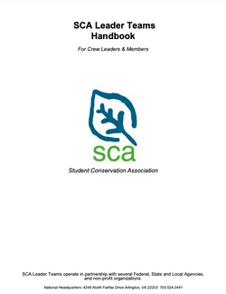
Volunteers for Outdoor Colorado
Trail Skill Training Document Downloads
North Country Trail Crew Leader Manual
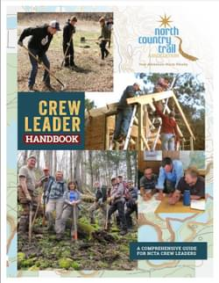

TRAINING VIDEOS

Trail Tool Videos!
These videos were created by the Colorado Springs Parks, Recreation and Cultural Services Department and provide general overviews of tool safety and common trail tools used in stewardship projects.
1. Tool Talks Overview
2. Tool Talk Set up and Earth Breaking Tools
3. Miscellaneous Trail Tools
4. Earth Moving Tools

PCTA Crew Leadership Class
Colorado Trail Foundation Crew Leader Manual
Appalachian Mountain Club Outdoor Leader Handbook
Ozark Trail Association Crew Leader Training Manual
Volunteers for Outdoor Arizona Crew Leader Manual

