Create a Better Binding

“To Piece is Fun, to finish is an Accomplishment.” What a saying. It is true. How many of us finish our quilt top and then have it quilted then never put the finishing touch on it? Bindings are the last step and yet some of us get stuck at that point. Don’t let this stop you from finishing your beautiful quilt. Create a better binding by learning a variety of shared techniques and tips. From calculating yardage, adjusting seam allowance, binding square corners, and easy ways to join ends along with finishing by machine and hand.

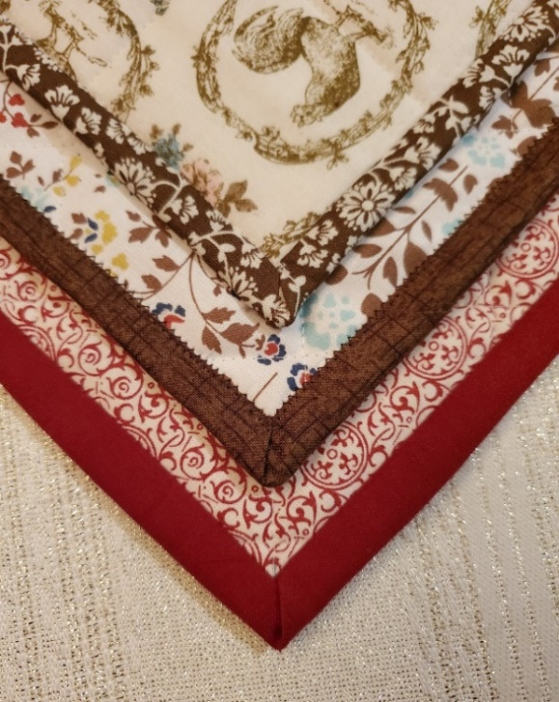

Supplies: Materials:
Sewing machine in working condition Two-quilted 15 inch squares
Open toe foot (You can make these or buy them)
Walking foot Half yard for binding.
Stitch n Ditch Foot
#12 or #14 Universal Machine needle
50 Weight thread to match binding fabric
#10 to 15 size sewing needle (whatever your prefer)
Marking pin
Measuring gauge
Quilting Klips
Marking ruler
Snip Scissors
Rotary cutter with small cutting mat for trimming
Ruler to cut strips for binding
Fabric Glue stick

Cut you binding before class. 2 ½” wide strips WOF

Please support you local Beaverton Montavilla Store for purchasing of supplies. Thank you!

