The Mart Chicago Vendor Rental Order Form
MARQUEE EVENT RENTALS – SANDY SOBCZAK
MARQUEE EVENT RENTALS - STEPHANIE D'AMBROSIO & JACLYN LEE
Please e-mail all forms to:
sdambrosio@marqueerents.com / jlee@marqueerents.com Any questions should be addressed by calling 708.237.9535
Please e-mail all forms to
ssobczak@marqueerents.com
Any questions should be addressed by calling 630.473.7274

Exhibitor: Booth #:
Contact Name: Contact Phone: Billing Address: Email Address:
Event Name: Date:

ORDER FORM
ITEM DESCRIPTION |  | COST PER ITEM |  | QUANTITY | COLOR | TOTAL COST
STAGING
Stage, 4'x4'x8" AS 2100 Biljax |  | $45.00
Stage Skirting 8'x8" (per section) |  | $26.38
Stage Covering, Black Turf |  | $1.25 (sq. ft)
Red Carpet Runner (4'W) |  | $9 (linear ft.)
CHIAVARI BALLROOM CHAIRS
Chiavari Chair  Black, White, Gold, Silver or Natural Wood |  | $13.49
Fruitwood Chiavari |  | $14.54
Tie-on Cushion Cap  White, Ivory or Black |  | No Additional Charge
Colored caps w/ hard bottoms |  | $3.75
CHAMELEON CHAIRS
Antique Gold Chameleon |  | $16.50
Silver Chameleon |  | $16.50
Chloe Topper |  | $12.00
LINENS | Lamour | Bengaline | Poly
90" round | $33.00 | $34.49 | $14.99
90"x132" banquet | $40.56 | $41.99 | $35.24
90"x156" banquet | $45.20 | $46.49 | $37.49
Circle linen desired and list color choice
TABLES
6'x30" Banquet |  | $14.69
8'x30" Banquet |  | $14.99
12" Leg extensions (Set of 4) |  | $14.99
Cab Tables - 30" or 36" round |  | $14.25
Highboy - 30" or 36" round |  | $20.99
Delivery fee is $89 round trip
Once order form is received we will email you the quote along with an electronic payment link.
We are a full service rental company! To view our entire product catalog visit our website at:
marqueerents.com

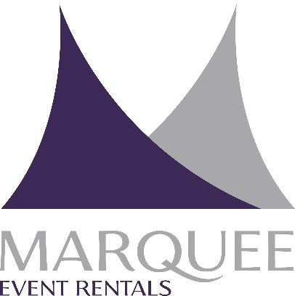
Please complete & email
Stephanie D'Ambrosio / Jaclyn Lee

to: ssobcazk@marqueerents.com

Salesperson name:
Sandy Sobczak

Authorization to Charge Credit Card
By signing below, I / We authorize Marquee Event Rentals to charge my / our American Express / Visa / Master Card / Discover Card for rentals or purchases from Marquee Event Rentals. We further authorize Marquee to charge the card for losses, damages and or cancellations fees that may occur as a result of the rental of Marquee's equipment.

Rental Contract #: Rental Amount: Date of Service:

X Credit Card Holder's Name:

X Billing Address of card holder:
(This must match ccd company records)

(Please Print Legibly)

(Street Address)

X Card Holder Phone Number: X Credit card #:
X Expiration Date: Amount to be charged:
(City, State & Zip Code)

(Please Note: There may be additional charges once final invoice is issued)

credit card type: security code
(Number is usually on the back of card)

Additional notes:

X Keep Credit Card on file: Yes No

X Signature:

X Printed Name: X Date:

Please note: All information provided will be verified for accuracy. If the name on the account and the address do not match an alternative payment method will be required. All of the above information will be kept secure.

Marquee Event Rentals • 9480 W. 55th Street • McCook, IL 60525

