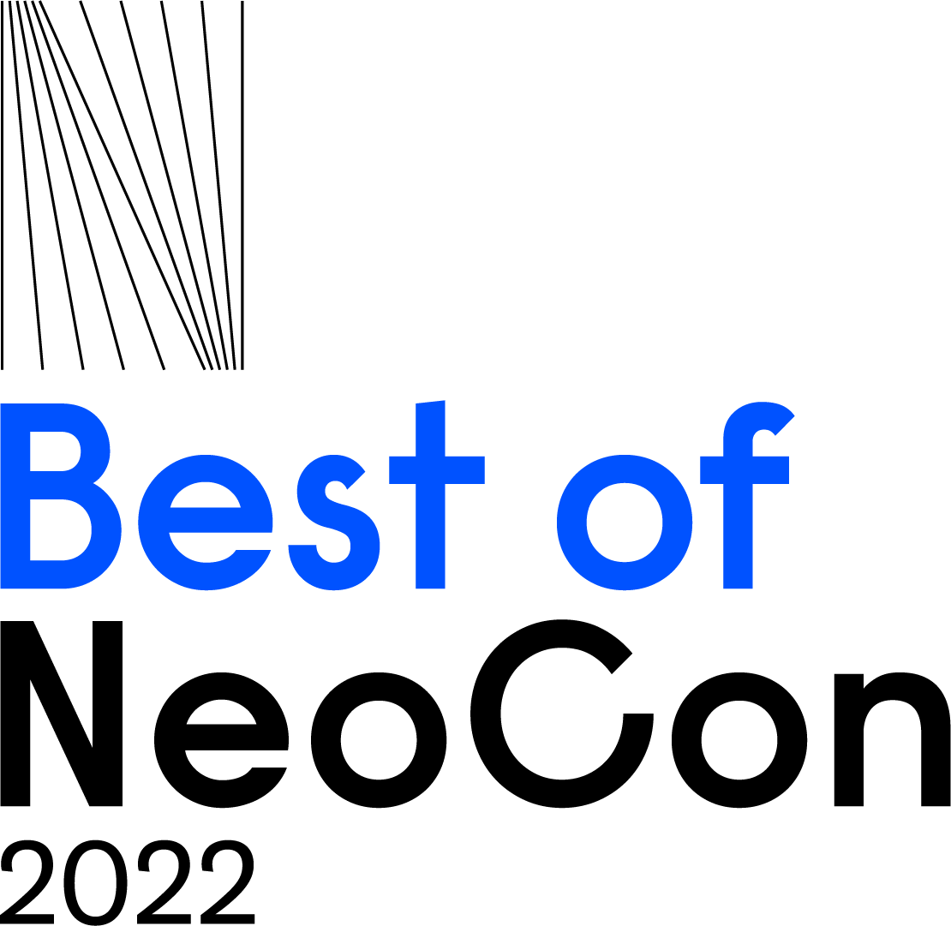

BEST OF NEOCON ANNOUNCES 2022 JURY LINEUP
More Than 45 Industry Experts Set to Judge Hundreds of Submissions
on Excellence and Innovation in Commercial Design

(Chicago, IL - April 2022) With NeoCon 2022 just over a month away (June 13-15), theMART is pleased to share a list of the highly vetted industry professionals who will be serving as jurors for the 32nd edition of the Best of NeoCon Awards. Each year, the Best of NeoCon Awards are juried by a select group of influential designers, architects, facility managers, and enterprise clients who understand the ever-changing needs and emerging trends critical for the commercial design industry. These jurors represent a wide cross-section of the greater NeoCon community, including members of top design associations, such as ASID, IIDA, AIA, IFMA, and NOMA. They are leaders in the key NeoCon verticals from healthcare, education, tech, and office interiors, and hail from top design, tech, and enterprise companies including HOK, Honda, Studio O+A, and Oracle, to name a few. The full list of jurors can be found on the Best of NeoCon site.

"One of the hallmarks of Best of NeoCon is its esteemed jury. Each year, we tap a select group of veteran jurors to return and team them with new jurors so the institutional wisdom and the process is maintained over decades," says Best of NeoCon Director Eileen McMorrow, who has been vetting jurors for over 30 years. “An important qualification is that all members of the jury are actively specifying for projects in the commercial verticals that the show covers. Interested jurors are screened with questions about their interior design or facilities planning projects, which helps us determine who should serve on the education or healthcare jury teams, for example, and who is more engaged with commercial office clients. This tailored approach makes for a valuable and productive educational experience for both the jurors and the exhibitors they visit during the judging process.”

“NeoCon allows for a valuable opportunity to get an in-depth look into the design stories behind each product,” comments Alexandria Davis, juror and designer/associate at IA Interior Architects. “It’s the conversation that is so precious to me. Being a juror for NeoCon drives this illuminating dialogue between creatives and their different perspectives. How one may interpret the use of a product vs. its intention can be worlds apart. It challenges how we may interact with the world, that is really special.”

Best of NeoCon jurors will arrive in the days leading up to the show to make their selections. Jury members are split into teams and visit all participating showrooms and booths, thoroughly evaluating all submitted products for consideration. This gives the jury teams and exhibitors dedicated time for in-depth product reviews. It also gives competition management the chance to prepare for the prestigious Best of NeoCon Awards ceremony, where all of the winners are revealed and celebrated before the start of the three-day show. The live awards ceremony will take place on Monday, June 13, at theMART and will also be live-streamed online through the NeoCon Hub. Due to popular demand, beloved publisher/editor in chief of officeinsight and NeoCon heavyweight Bob Beck will return as this year’s Master of Ceremonies for the official awards celebration to announce the winners.

“I’m thrilled to be returning as a Best of Neocon juror for 2022,” comments veteran juror Lauren Perich, interior designer at Studio O+A. “This year, I'll be keeping an eye out for products and solutions that have a focus on where the future of the workplace is headed: inclusion, flexibility, adaptability, environmental circularity, the living product challenge, and carbon neutrality.”

This year, exhibitors can submit in 54 categories that encompass all contract trends and workplace needs, from Conference Room Furniture and WorkPods to Performance/Specialty Textiles and more. A complete list of categories is available here. Jurors will select a Gold and Silver winner in these categories with some final stand-out winners for Innovation, Sustainability, and Best in Competition.
More details on the program and entry process can be found at neocon.com/programming/best-of-neocon. The show is open to trade, C-Suite executives, and other industry-related professionals at neocon.com/register. For additional details and to register for NeoCon 2022, head to neocon.com.
For showroom, exhibitor, and general NeoCon news, images, and real-time information follow NeoCon on: Facebook (@NeoConShows), Twitter (@NeoCon_Shows), Instagram (@NeoCon_Shows), and Linkedin (@NeoCon-Shows).
Media Contacts: Novità Communications
Alexandra Zwicky / Danielle McWilliams / Emma Reuland / Katie Fosdick
# # #
About NeoCon: NeoCon is the world’s leading platform and most important event for the commercial interiors industry, held each year at theMART in Chicago. Since launching in 1969, NeoCon has served as the annual gathering place for the commercial design world’s manufacturers, dealers, architects, designers, end-users, design organizations and media. The three-day event showcases game-changing products and services from both leading companies and emerging talent—providing unparalleled access to the latest and most innovative solutions. A robust educational program of keynote presentations and CEU sessions offers world-class expertise and insight about today’s most relevant topics as well as the future of commercial design. www.neocon.com

NeoCon® is a registered trademark of Merchandise Mart Properties Inc, a subsidiary of Vornado Realty Trust.

About theMART: theMART (formerly The Merchandise Mart), located in the center of the sought-after River North submarket, is interwoven into the fabric of Chicago as an innovator in business, technology, culture, art, media and more. As the largest privately held commercial building in the United States, it is one of the world’s leading commercial buildings, wholesale design centers and the preeminent international business location in Chicago. Encompassing 4.2 million gross square feet, theMART spans two city blocks, rises 25 stories, and is visited by an average of 30,000 people each business day and nearly 10 million people annually. Offering continuous innovation and creativity from leading manufacturers and design forward showrooms, theMART serves as the home to Chicago's most creative and technologically innovative companies.

