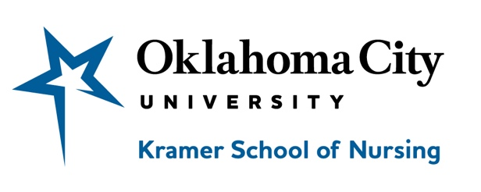

Post Master’s Certificate – Advanced Practice Program Outcomes

Academic year | Enrolled students  PMC Program | Graduation Rate*  (within 2 years) | Graduation Rate**  (within 3 years)
2018-2019 | 1 | 0/1 0% | 0/1 0%
2019-2020 | 10 | 10/10 (100%) | 10/10 (100%)
2020-2021 | 5 | In progress | In progress

Academic year | Enrolled PMC-FNP | Graduation Rate*  (within 2 years) | Graduation Rate**  (within 3 years)
2018-2019 | 1 (withdrew) | 0% | 0%

Academic year | Enrolled PMC-AGACNP Accelerated | Graduation Rate*  (within 1 years) | Graduation Rate**  (within 2 years)
2019-2020 | 10 | 10/10 (100%) | 0/10

Academic year | Enrolled PMC-AGACNP Traditional | Graduation Rate*  (within 2 years) | Graduation Rate**  (within 3 years)
2020-2021 | 5 | In progress | In progress

www.okcu.edu/nursing

