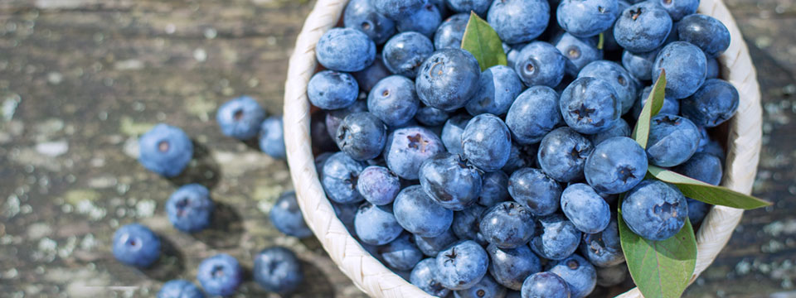
  - Oregon Blueberries are coming!
Just when we thought we were out of the woods, we are starting to see some issues with Liberty Dieback; Bluecrop and Aurora varieties exhibiting some dimension of the same problem. This will be a difficult issue to pin down considering some fields are perfectly fine and others have 20% or more plants showing varying degrees of severity. Working backward to pre-heat dome is happening right now to gauge physiological response that some fields may be exhibiting.
All fruit is swelling and most bees have been removed from the fields. We are getting ready for a sizable crop outside of the previously mentioned varieties. We anticipate harvest starting around July 6th (some folks are pushing for July 3rd) in Oregon.
.

Oregon Berry Crop Update – June 7, 2022
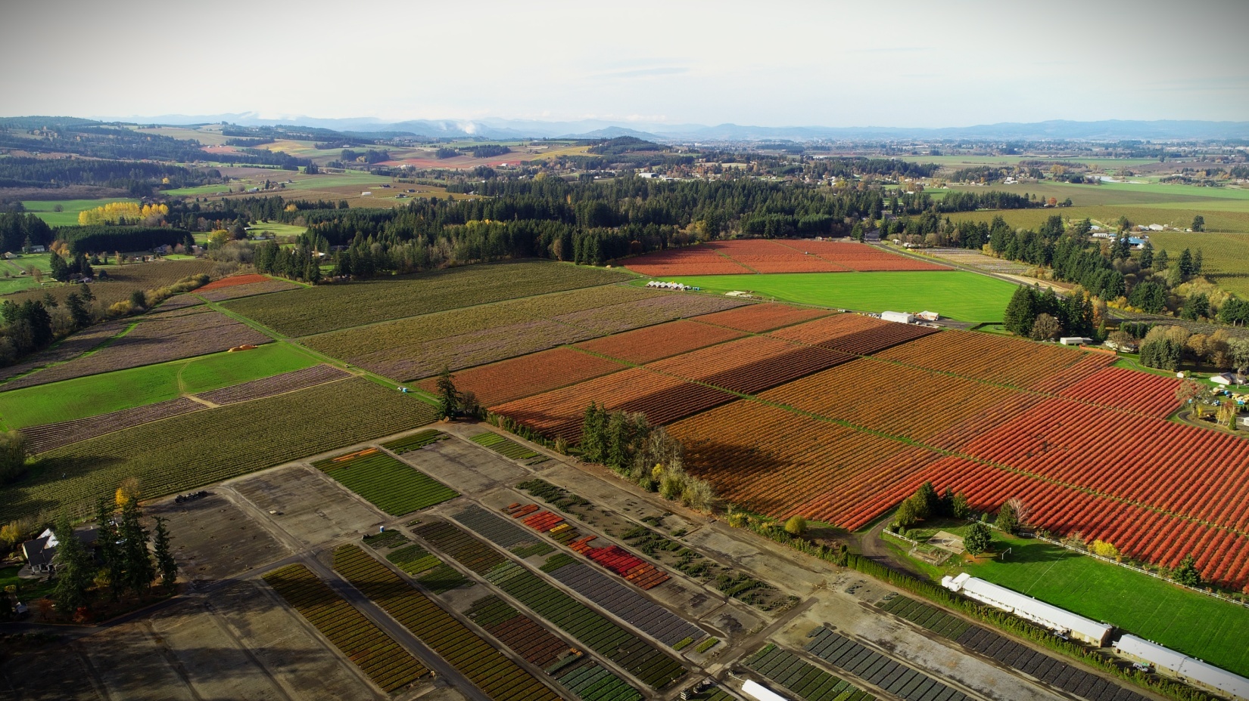
We are anticipating a great 2022 with more predicted volume of high quality blueberries from our farms. Duke season is set to begin around July 4th, finishing with Last Call towards the end of September. This year, we will keep you updated on each export variety we are working with and show growth week by week.

Duke
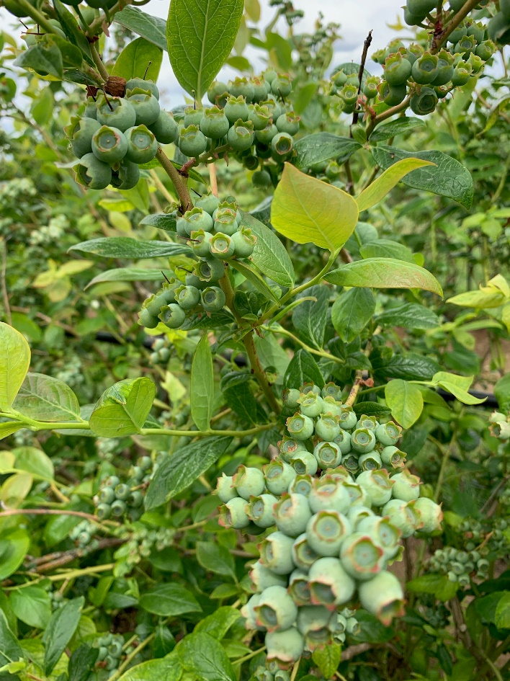
Duke blueberries are the leading, early-ripening Northern Highbush variety. It is known for its high yields, uniformed size and superior quality fruit.
Fruit characteristics: Light blue, firm, mild flavor
Timing: Late June-Mid July
Size: Large

Draper
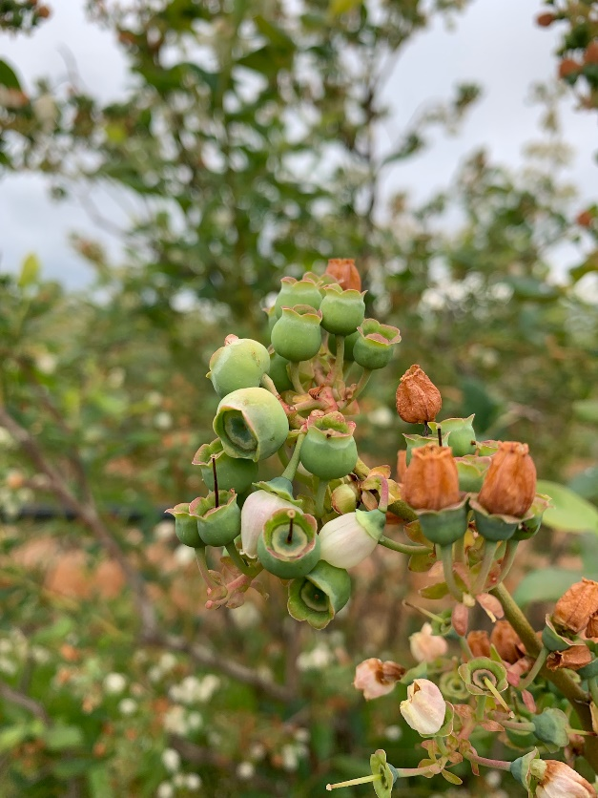
The Draper blueberry is exceptionally firm with concentrated ripening periods. The berries have excellent post-harvest color retention and superior shelf life.
Fruit Characteristics: Light blue, firm, crisp, sweet flavor
Timing: Early July-Late July
Size: Large

Liberty
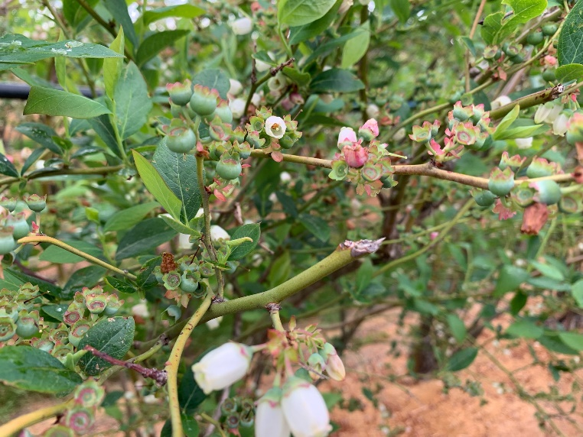
Liberty blueberries are sky-blue in color and have a balanced, appealing flavor. This variety has excellent bloom.
Fruit Characteristics: Light blue, balanced flavor
Timing: Late July-Early August
Size: Large

Calypso
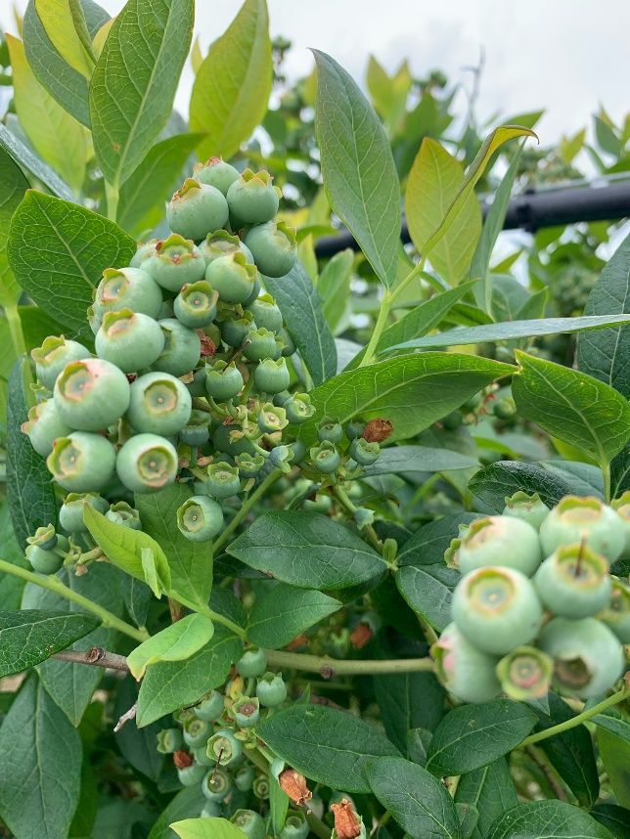
Calypso produces a firm, large berry with excellent flavor and a small dry scar. Fruit ripens uniformly, producing a very consistent size and durable in travel.
Fruit Characteristics: Light blue, classic flavor
Timing: Late August-Late September
Size: Large-Very Large

Top Shelf
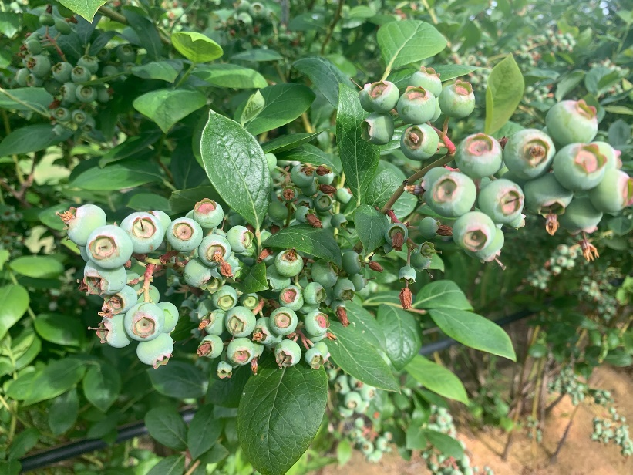
Top Shelf blueberries are notable for their very large, flavorful, firm fruit. While similar to Draper in many ways, Top Shelf blueberries seem to excel in areas such as plant vigor, fruit size and flavor.
Fruit Characteristics: Sky blue, tropical flavor, firm, juicy
Timing: Mid-Season, August
Size: Very Large

Last Call
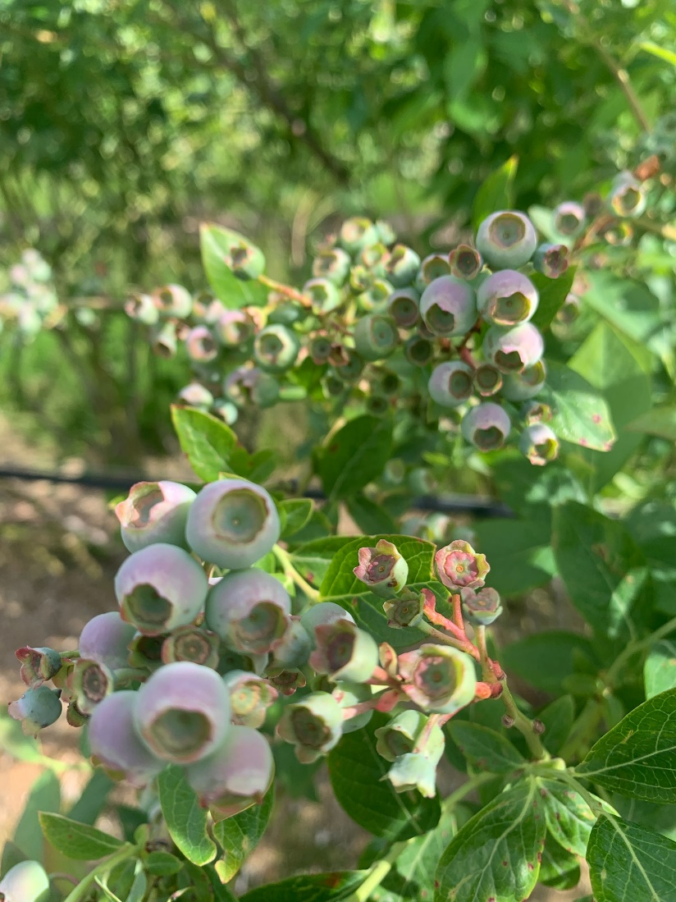
The Last Call blueberry bush produces high yields of large berries with a classic, sweet and slightly aromatic blueberry flavor. This berry has a nice crunch.
Fruit Characteristics: Very sweet, classic flavor, aromatic
Timing: Late-Season, End August-September
Size: Large

Peachy Blue – New Variety
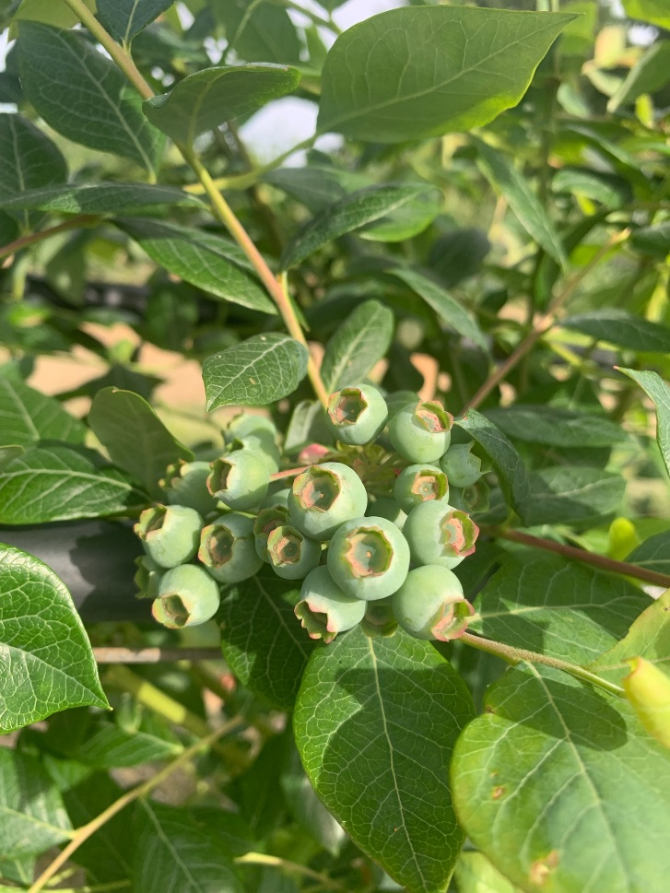
This is one of the new, crunchy varieties we have been talking about. This berry has exceptional flavor and optimal shelf life. Oregon Berry has made the commitment to only grow the best eating varieties, allowing you to move fruit easily and guaranteeing premium Oregon Berry quality! Quantities will be limited and are not guaranteed to export until we get closer to the season to assure quality.
Fruit Characteristics:
Timing: Mid to Late Season
Size: Large

