PArtner lender/servicer outreach toolkit
As key partners of the Louisiana Homeowner Assistance Fund, we hope you will use the included resources to connect those who may benefit from mortgage assistance with available program funding.
For more information or materials request, please email info@lacovidhousing.com

Example Email Sent to Homeowners on Lender Behalf
Dear ________,
We are writing to make you aware of the Louisiana Homeowner Assistance Fund (LA HAF) program, a federally funded financial relief program for homeowners financially impacted by COVID-19 who are behind on their mortgage and at risk of foreclosure.
This program is meant to provide mortgage assistance to Louisiana homeowners and, if you are behind on your mortgage and at risk of foreclosure due to impacts from COVID-19, you may be eligible for program assistance.
LA HAF may provide up to $25,000 per eligible homeowner and is available statewide. This program is not a loan program, meaning you will not need to pay back program funds, and there is no interest attached to the payments. All homeowners who may be eligible are encouraged to apply.
This assistance program is meant to provide you the means to keep your home during these difficult times. As of September 1, the program has approved over $31 million in mortgage assistance for Louisiana families.
General eligibility criteria include:
- Own and occupy a home in Louisiana as primary residence
- Meet income qualifications
- Experienced a financial hardship associated with the COVID-19 pandemic
- *Be more than 30 days delinquent on your mortgage
*Applicants whose mortgage is current but are facing financial hardship related to the pandemic may qualify for up to three future payments (hardships include currently receiving unemployment benefits, received at least three weeks of unemployment per quarter in the current year, or experienced unvoluntary household changes in the current year).
We have attached the program flyer for additional information. The Louisiana Office of Community Development is administering the program, and the program is funded through the American Rescue Plan Act.
To learn more, explore available resources, and start your application, visit haf.lacovidhousing.com.
If you have questions about the program or need assistance in submitting an application, please email info@lacovidhousing.com.
Sincerely,
____________

Social Media Graphics + Template Copy

CAPTION 1:
Are you struggling to pay your mortgage due to impacts of COVID-19?
The Louisiana Homeowner Assistance Fund program is available to eligible homeowners.
Learn more and apply for assistance today at haf.lacovidhousing.com.

CAPTION 2:
The Louisiana Homeowner Assistance Fund provides mortgage assistance to Louisiana homeowners financially impacted by COVID-19 and struggling to pay their mortgage.
Learn more and apply today at haf.lacovidhousing.com.

CAPTION 3:
If you are behind on your mortgage due to impacts of COVID-19, help is available.
The Louisiana Homeowner Assistance Fund provides mortgage assistance of up to $25,000 to eligible Louisiana homeowner.
Learn more and apply today at haf.lacovidhousing.com.
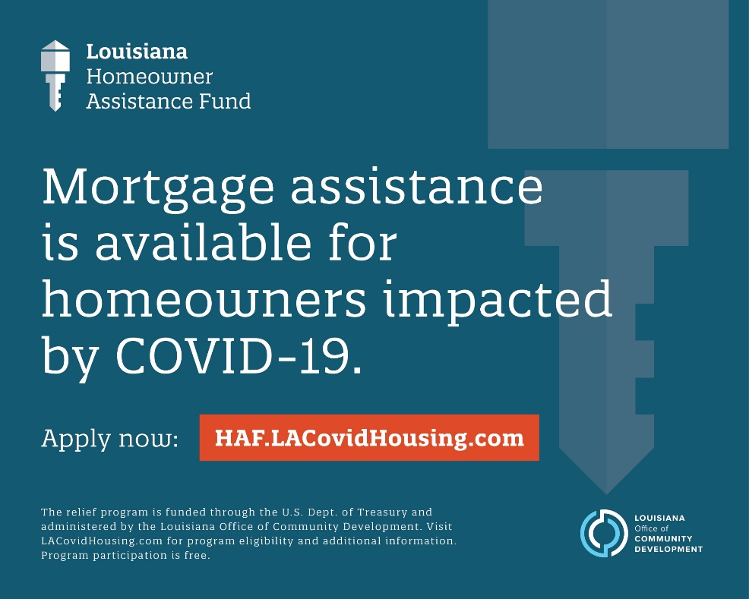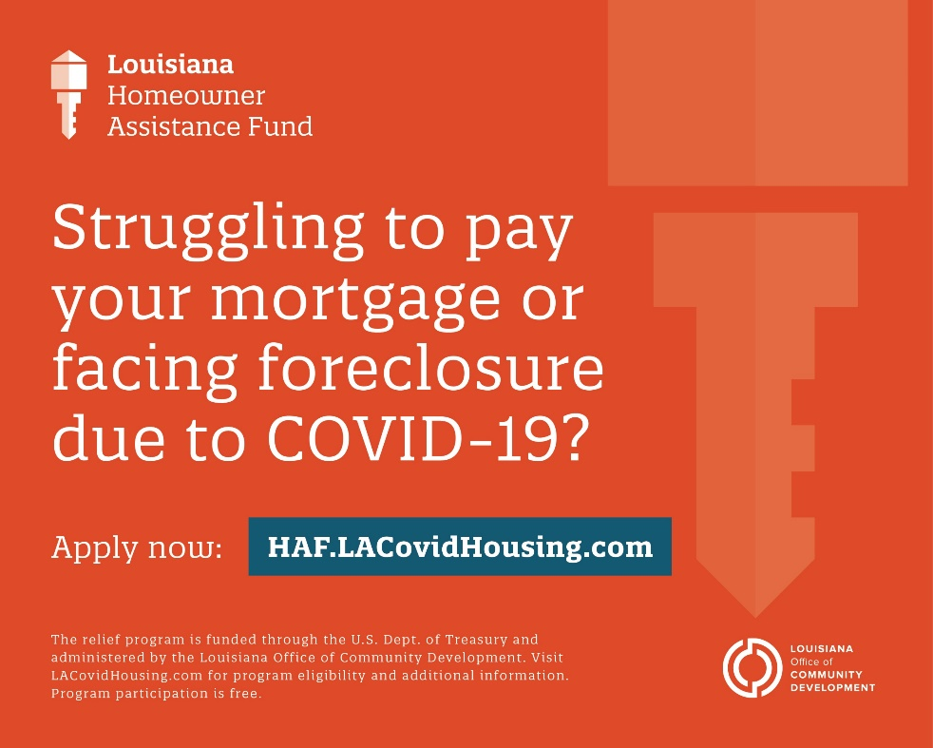
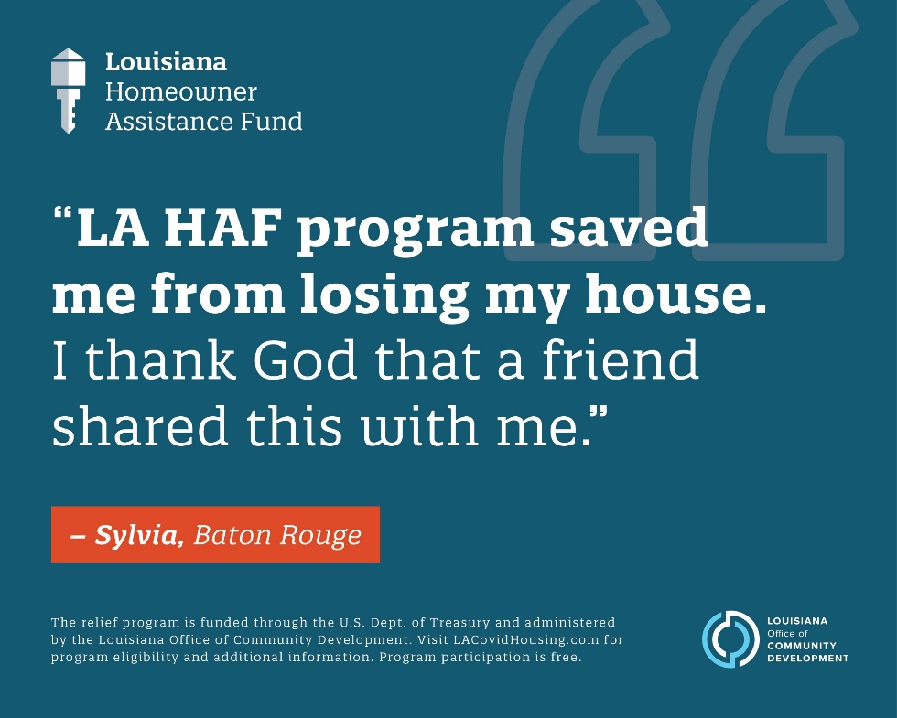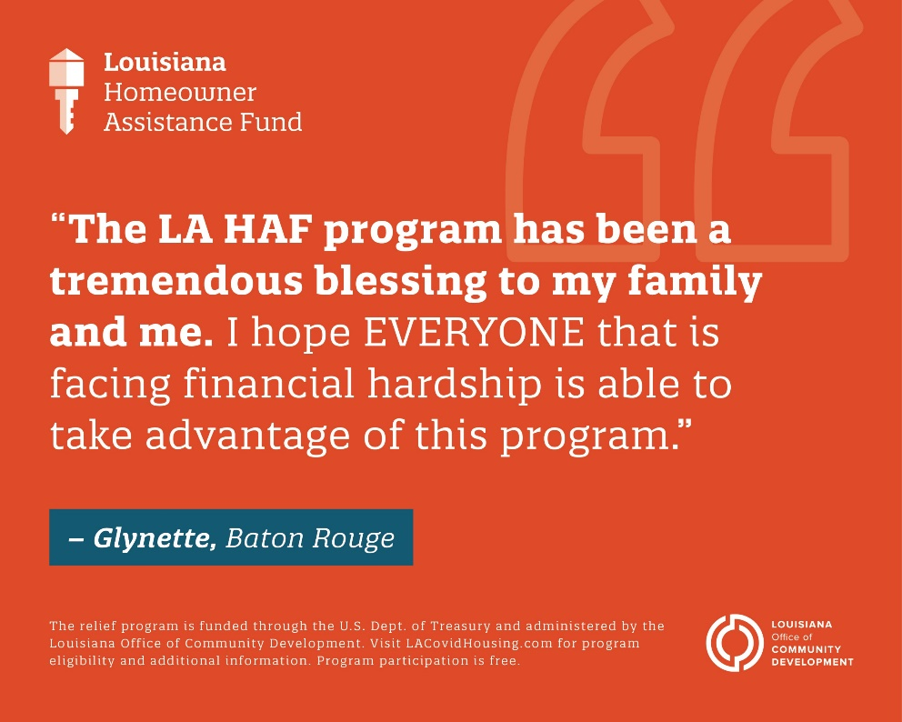

HAF Program Factsheet

overview
- The Louisiana Homeowner Assistance Fund is a federally funded relief program for homeowners financially impacted by COVID-19 who are behind on their mortgage and at risk of foreclosure.
- The program will provide direct financial relief to homeowners with low- to moderate- incomes most at risk of losing their homes to foreclosure.
- The program is funded through the U.S. Department of Treasury and is being administered by the Louisiana Office of Community Development.
- The Louisiana Homeowner Assistance Fund program launched on January 10, 2022.
- The state of Louisiana has received $146.7 million for the program through the American Rescue Plan Act (ARPA).
- The program will provide up to $25,000 in mortgage assistance to eligible Louisiana homeowners.
  - The state has established this $25,000 cap based upon best available data to maximize the number of homeowners served.

Eligibility Requirements
- The program is available to homeowners experiencing financial hardship after Jan. 21, 2020, associated with the COVID-19 pandemic, and earning less than 150 percent of the area median income or 100 percent of the national median income, whichever is greater, based on U.S. Department of Housing and Urban Development income data.
- Priority will be given to individuals earning less than 100 percent of the area median income.
- Eligibility requirements include:
  - Own and occupy the home in Louisiana as primary residence;
  - Household is income qualified; and
  - Experienced hardship associated with COVID-19

Program Accessibility and Available Resources
- The state has made it easy for homeowners to find information and apply to the LA HAF program through the program website at haf.lacovidhousing.com.
  - Homeowners may access and submit an application via the website portal, or call the call center for support in starting the application as well at 833-88-LAHAF.
- The LA HAF website provides resources to guide prospective applicants through the application process, FAQs, and program overview and contact information.
- If you have any questions or would like additional information, please email info@lacovidhousing.com, which is actively monitored by the program team, or call 833-88-LAHAF (833-885-2423), open 8 am – 5 pm, Monday through Friday.

Program Resources
The Louisiana Homeowner Assistance Fund has a collection of resources and materials available for distribution. Hyperlinked are some of these resources, but please reach out to the program team if there is anything else we can provide to you for easy distribution to your networks and customers.
- Program one-pager
- Program overview
- Program application user guide
- Program application journey
- Applicant guidelines
- Frequently Asked Questions (Frequently asked questions for the Louisiana Homeowner Assistance Fund program can also be found online at haf.lacovidhousing.com/FAQs)

