Author: Head of People and Culture

Policy Review Date: 04th December 2025

SUMMARY

This document sets out the West London Waste Authority (WLWA) Whistleblowing Policy in full and should be referred to for official guidance and interpretation.
To ensure it is accessible, we can provide this policy in alternative formats—such as Easy Read, large print—on request. These formats are designed to support individuals with different communication needs.
If you require this document in another format, please contact People and Culture Services at hr@westlondonwaste.gov.uk

Document Control

Version: 1.3

Superseded: January 2022

Next Review Date: January 2027

Table of Contents
Author: Head of People and Culture 1
Policy Review Date: 04th December 2025 1
SUMMARY 1
Document Control 2
Version: 1.3 2
Superseded: January 2022 2
Next Review Date: January 2027 2
1. Purpose 2
2. Duty to Report 3
3. Protection for Employees 3
4. When should the Policy be invoked? 3
5. Who does this Policy cover? 4
6. Financial Irregularities 4
7. Process 4
8. Appropriate Links to Cross-Reference 7
9. List of Relevant “Prescribed Persons” 7
10. Review and Governance 7
12. Appendix 1: Process Flow “How WLWA will Respond” 8

Purpose
  - West London Waste Authority recognises the importance of maintaining integrity within the organisation. Staff are expected to take responsibility for their roles, the working environment, and the Authority’s objectives. When employees become aware of wrongdoing, it is essential that this information is reported promptly and without hesitation.
  - The Whistleblowing Policy serves two primary purposes:
    - To establish a straightforward and secure process for staff to report concerns.
    - To facilitate the collection of information regarding these concerns and, following investigation, to determine the necessary actions to address them.

Duty to Report
  - WLWA priorities and its services could be severely jeopardised if employees are engaged in any form of wrongdoing. WLWA is reliant on such matters being reported in order that they can be addressed, and if applicable stopped. WLWA’s Code of Conduct places a duty on employees to report promptly any suspicions of fraud, theft or other wrongdoing.
  - The types of activity that should be disclosed include, but are not limited to, the following:-
    - Fraud or corruption
    - Financial maladministration
    - Failure to comply with legal obligations
    - Endangering of an individual’s health and safety
    - Damage to the environment
    - A criminal offence
    - Failure to follow financial and contract procedure rules
    - Miscarriage of justice
    - Deliberate concealment of information relating to any of the above.
  - Some examples might be:
    - A danger in the workplace
    - An act of fraud within WLWA
    - Someone who is offering, taking or soliciting bribes
    - Misreporting performance data
    - Inappropriate conduct or behaviour affecting children or vulnerable adults.

Protection for Employees
  - WLWA Authority Members, Officers and the Senior Leadership Team are committed to this policy.
  - Staff who raise a genuine concern under this policy will not be at risk of suffering any form of detriment as a result.
    - Provided that Staff raise the matter honestly, it does not matter if the concern is mistaken.
    - However, any concern raised maliciously, which is known to be untrue, may lead to disciplinary action as this is considered misconduct.
  - All disclosures will be handled and treated sensitively and confidentially, and with appropriate support in place for the individual speaking up.
  - WLWA will not tolerate the harassment or victimisation of any staff member raising a genuine concern.

When should the Policy be invoked?
  - If staff have a genuine concern about possible wrongdoing at work, as specified above, they should report it under this Policy.
  - Where staff are aggrieved about issues directly affecting them, they should use the Grievance Policy to pursue their concerns.

Who does this Policy cover?
  - This policy applies to all employees, officers, consultants, contractors and agency workers.

Financial Irregularities
  - Internal Audit must be informed whenever a concern, regarding financial matters, is reported.
  - Nothing in this policy overrides WLWA’s duties and responsibilities as set out in the “Financial Regulations of WLWA”.

Process
  - Advice and Support
    - WLWA recognises that staff may wish to seek advice and support from the recognised trade union representatives before blowing the whistle. Alternatively, advice may also be sought from “Protect”.
      - Protect is a service WLWA engages to provide a free, confidential advice service that specialises in whistleblowing. Their website is Protect - Speak up stop harm - Whistleblowing Homepage. They can be contacted by telephone on 02031172520.

  - Confidentiality
    - WLWA hopes that individuals will feel able to voice whistleblowing concerns openly under the policy.
    - However, if the individual wishes to raise concerns confidentially, WLWA will make every effort to keep their identity confidential.
    - All concerns reported under the Whistleblowing Policy will be handled sensitively and discreetly.
    - Obligations rest on all parties involved, including the Whistleblower, to do their utmost to protect the identity of the person reporting the concern if that is their wish.
    - Should there be any exceptional circumstances where the whistleblower’s identity has to be disclosed (for instance, if any case went to court), this would be discussed with them beforehand.
    - Any breaches of confidentiality may be considered under WLWA’s Disciplinary Policy.

  - How to Raise a Concern
    - Anyone who has a concern about wrongdoing should first raise it with their line manager or a more senior manager.
    - If there is a personal interest in the matter, they should inform the manager at the outset.
    - If it is felt that the concern cannot be raised with the line manager, for whatever reason, there are other people within WLWA to whom the concern can be reported:
      - Head of People and Culture
      - Managing Director
      - Director of Finance and Corporate Resources
    - If the concern relates to possible fraud, corruption, financial malpractice or bribery, under the Bribery Act 2010, you are asked to raise the matter directly with the Treasurer, who is best placed to deal with such issues.
    - If it is felt that the matter is so serious that you cannot discuss it with any of the above, then you should contact the Clerk of the Authority.
    - WLWA would prefer you to always raise any concerns promptly, regardless of waiting for or seeking proof independently.

  - How WLWA Will Respond
    - For issues reported outside of line management
      - When an issue is reported outside of the line management, the person receiving the concern (i.e. one of the named postholders outlined in 7.3.3.1, 7.3.3.2 and 7.3.3.3 or 7.3.4 and/or 7.3.5) will assess the concerns and determine whether or not further investigation is appropriate.
      - Where further action is required, the recipient will send a factual report to an appropriate manager asking them to investigate. If the whistleblower wants their identity to be kept confidential, then this will not be disclosed to the investigator.
      - In certain exceptional circumstances, the recipient may need to refer the concern to an appropriate authority, e.g., the Police, the External Auditor, or they may need to discuss with the Clerk of the Authority the option of an independent enquiry involving people from outside WLWA.

    - Issues reported to the Line Manager
      - When an issue is reported to the line manager directly, the manager should consider the most appropriate means of dealing with the concern.
      - The manager may wish to take advice, either from their own manager or from one of the postholders referenced under 7.3.3.1, 7.3.3.2 and 7.3.3.3 or 7.3.4 and/or 7.3.5, before proceeding.
      - If the whistleblower wishes their identity to be kept confidential, the manager and the whistleblower must ensure that this is the case in any investigation of the concern.
      - The line manager must notify one of the postholders referenced under 7.3.3.1, 7.3.3.2 and 7.3.3.3 or 7.3.4 and/or 7.3.5 that a concern has been reported and of the outcome of any investigation. This is for monitoring purposes.

  - Investigation

    - Outset
      - The investigating manager must have had no involvement in the concerns under investigation and must not be in a position where they have, or it could be perceived that they have, any interest in relation to the matter.
      - Should any further information be required from the whistleblower and their identity is being kept confidential, the investigation manager will discuss this with the named postholder referenced under 7.3.3.1, 7.3.3.2 and 7.3.3.3 or 7.3.4 and/or 7.3.5, who will be responsible for contacting the whistleblower.
      - At the conclusion of the investigation, the manager may wish to make recommendations, or there may be action required under employment relation policies.
      - Where further action is required, which involves the investigating manager's direct reports, the manager should proceed accordingly, notifying their line management if appropriate.
      - Where further action is recommended in respect of other staff, the investigator should contact the relevant line manager and discuss an appropriate way forward.

    - Notification
      - The investigating manager must forward a copy of their report to the named postholder who referred the case to them, along with a note of any further action proposed.

    - Contact with the Whistleblower
      - Once an individual has reported the concern, there should not be a need for any further input from them during the process, unless they need to be interviewed as part of the investigation.
      - The named postholder to whom the whistleblower raises the concern should consider whether further support for or liaison with the whistleblower is appropriate and take any steps necessary.
      - The named postholder to whom the concern was raised will provide any feedback on the final outcome, where it is appropriate to share. This may mean the whistleblower does not receive any feedback beyond an acknowledgement that their concerns are being reviewed.

    - Malicious Complaints
      - If there is a malicious complaint raised, which can be proved that there is knowledge of the concerns being untrue, this will be treated as misconduct and may lead to disciplinary action being taken.

    - Anonymous Reports
      - Where there are concerns reported anonymously, it is much more difficult for the matter to be looked into.
      - Consequently, anonymous reports will be considered at the discretion of the person to whom the matter is reported.

    - Raising a Concern Externally
      - WLWA would prefer for all concerns to be raised internally within the first instance and wishes to foster confidence in the internal reporting mechanisms set out in this policy.
      - It would be preferable for any concern you feel unable to raise internally to be raised with our independent internal auditor. Contact details of these can be requested from People and Culture Services.
      - However, WLWA would prefer that concerns be raised with an appropriate external contact rather than not at all.
        - If this is the case, providing there is reasonable belief and evidence to back up any concerns, the following may be contacted:
          - A relevant prescribed regulatory body as referenced under 9.2.1 in this policy.
          - The police
          - Advice and support are also available from “Protect” referenced under 7.1.1.
        - We do, however, strongly advise you to seek advice internally before reporting a concern externally.
        - It is important to note that should a concern be raised externally, there are more stringent criteria which must be complied with you are to receive the protection offered by the Public Interest Disclosure Act.

    - If you are Dissatisfied
      - Whilst WLWA cannot guarantee that it will respond to all matters in the way that individuals reporting them may wish, we will endeavour to handle all matters fairly and properly.
      - If the process set out in the Policy has been followed and you still believe that wrongdoing is continuing, or are unhappy with the response, you can refer to other levels and named bodies within this policy.
      - If you are aggrieved about an action which has been taken, or is considered being taken, against you as a result of invoking this policy you have the right to lodge a grievance under WLWA’s Grievance Policy.

Appropriate Links to Cross-Reference
  - The following documents relate to Whistleblowing Policy and may be useful. They are available from People and Culture Services.
    - Grievance Policy
    - Code of Conduct
      - Whilst WLWA cannot guarantee that it will respond to all matters in the way that individuals reporting them may wish, we will endeavour to handle all matters fairly and properly.

List of Relevant “Prescribed Persons”
  - Those who feel unable to raise a concern with one of the postholders listed above may wish to disclose concerns to one of the following prescribed regulatory bodies. In doing so, you must have a reasonable belief that the matter is true:
  - The full list of prescribed regulatory bodies is set out in the “Public Interest Disclosure (Prescribed Persons) Order 1999, as amended and are listed on the government website:
    - Whistleblowing: list of prescribed people and bodies - GOV.UK

Review and Governance
  - This policy is reviewed annually by People and Culture Services in collaboration with Governance to ensure continued alignment with public-sector standards and Government guidance.
- Further Information and Support
  - People and Culture Services: hr@westlondonwaste.gov.uk

Appendix 1: Process Flow “How WLWA will Respond”
For issues reported outside of line management
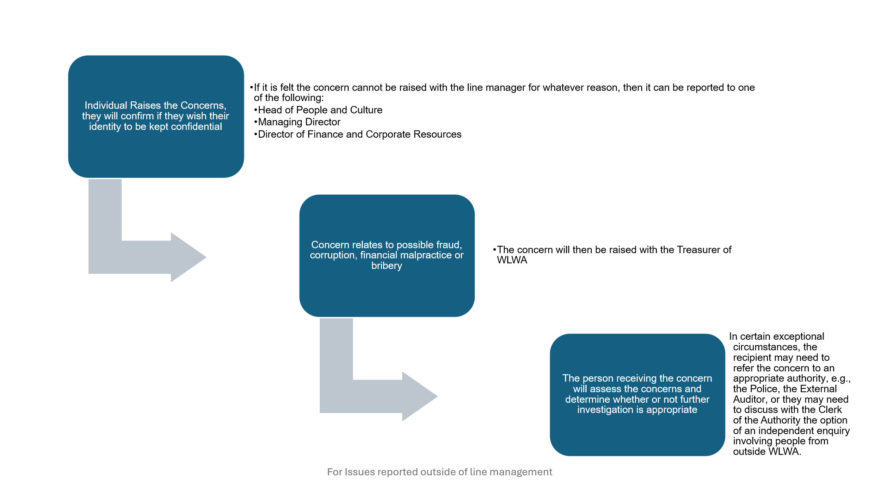
Issues reported to the Line Manager
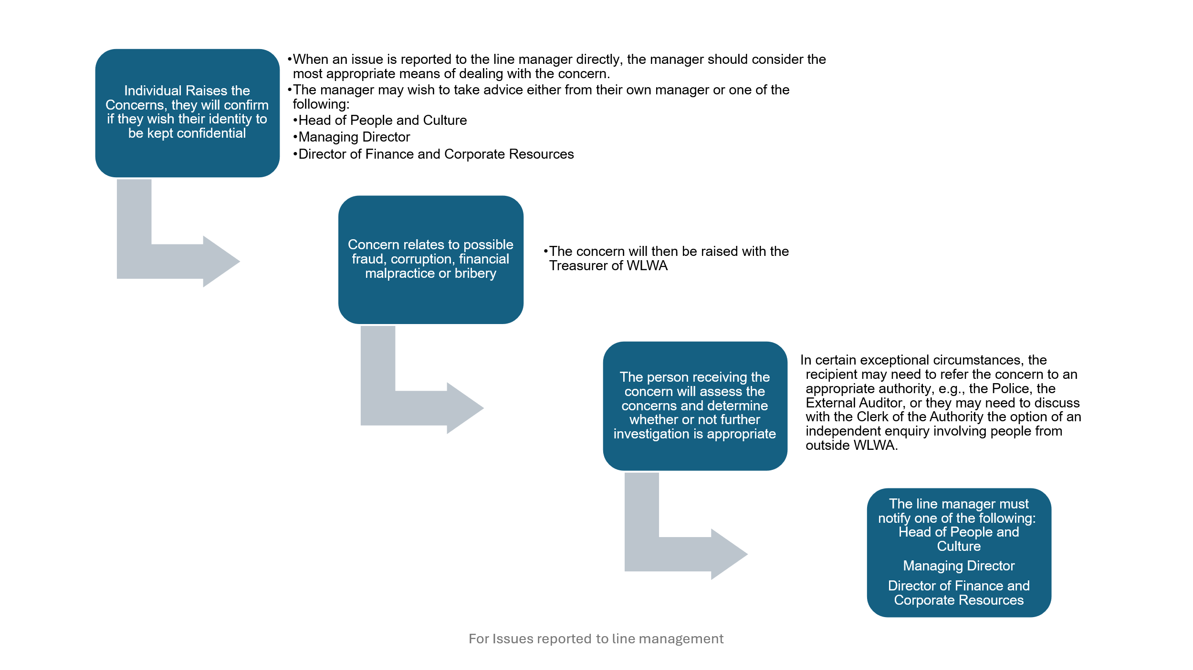

Investigation Process
