Job Description

West London Waste Authority
Job title: | Senior Project Manager
Responsible to: | Strategic Development Manager
Responsible for: | n/a
Budgetary responsibility: | £250,000 per annum
Main job function: | Project management and coordination of multiple specific waste infrastructure and recycling projects within a programme to deliver the Authority’s business plan e.g. increasing the value/quality of recycling materials collected, improving efficiency of borough collections, recycling service changes and developing infrastructure on existing sites, scoping and developing required infrastructure including gathering technical information, waste flow models, producing site assessments, submission of a planning applications and development of business cases.
Salary: | PO5
Basic hours: | 36 hours per week
Principal location:  Working arrangements: | Unit 6 Britannia Court, The Green, West Drayton, UB7 7PN  Attendance at the Authority’s office(s) and sites and contractors’ sites is required to effectively manage and mentor staff and contractors.

Duties and Responsibilities:

- Create, design, and deliver smart cities projects across all Boroughs and initiate operational change and advice through effective data capture and stakeholder management.

- Design and manage the change programme for Borough collections systems c.£10M operations per Borough. Including full-service re-routing, round design, stakeholder management and data management.

- To project manage and co-ordinate multiple complex waste and recycling projects including making recommendations to the Director of Circular Economy and Net Zero/Senior Leadership Team and ensuring that all changes to service provision and all associated activities are understood by the relevant stakeholders.

- Act as the ‘superuser’ of WM Design (Routesmart) software and utilise WM Design software for design and optimisation of waste and recycling collection rounds. For the purpose of:
  - Options appraisal – modelling various collection scenarios including joint authority services for the purpose of decision making.
  - Baselining the performance of existing collection services
  - Optimising existing collection services
  - Designing on demand new collections rounds for and including new collections services.
  - Liaise with borough partners to deliver work to required specification.

- To assist the Director of Circular Economy and Net Zero and Strategic Development Manager with the creation and maintenance of a project program which integrates all of the projects, waste flows and commercial understanding, reporting monthly to the Senior Leadership Team and quarterly to the project board.

- To work with Director of Finance, Director of Circular Economy and Net Zero and Strategic Development Manager to develop robust outline business cases for projects and service changes and negotiate changes and impacts with the relevant stakeholders through the Borough Partnership meetings and prepare reports for Senior Managers and the Authority.

- Offer project assistance as required or requested from borough partners to provide operational improvement or efficiencies.

- Support the Director of Circular Economy and Net Zero and Strategic Development Manager to deliver projects across all of the WLWA strategic priorities.

- Work with Senior Leadership Team to understand impact of the Resources and Wastes Strategy, ETS, EPR, DRS and Simpler Recycling on WLWA and partner boroughs. This understanding to be used to inform WLWA response to consultations.

- Ensuring data capture and analysis includes carbon measurements which links into WLWA’s overall carbon objectives of working towards carbon neutral by 2030.

- To liaise with the constituent boroughs and external bodies such as Defra, GLA and other Waste Disposal Authorities on the projects. Engage and manage the internal and external professional advisory teams covering areas such as planning, permitting, financial, legal and construction.

- Support the Head of Contracts and Procurement and partner boroughs with procurement of recyclable processing services and provide any further related assistance as required. This may include support drafting tender documents or reviewing tenders. Where possible procurements should take advantage of economies of scale open to multiple partner boroughs.

- Monitor composition data of dry recyclable materials from all partner boroughs and work with the data team to incorporate information into OpenSky.

- To monitor and manage the budget spend on projects and create and maintain all project documents and key activities including the project progress reports project risk registers, lessons learned log, project plans, weekly action logs and meeting records, and report these monthly to the Director of Circular Economy and Net Zero and quarterly to the project board.

- Undertake any other duties commensurate with the grade of the post, as may be required from time to time, including working from different locations, attendance at meetings outside of normal working hours and supporting activities that cover all the WLWA work.

West London Waste is continually reviewing its structures and ways of working in order to provide the best services possible for residents, in the most efficient way. As a result, through appropriate consultation with staff and representatives, the key tasks in any job may be varied and the post holder will be expected to take on such variations consistent with the level of responsibility of the post.

Person Specification
VALUES AND BEHAVIOURS
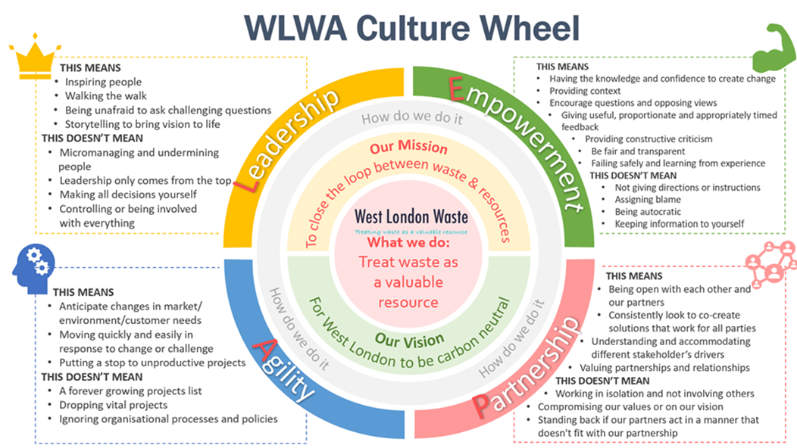
Values and Behaviours | Essential (E), Desirable (D) | Assessed by;  Application (A), Interview (I), Test (T) or Other (O)
I ensure the needs of different communities are understood and addressed.  I challenge others, and deal with challenges in an honest and constructive way.  I am a role model for the Authority’s behaviours and lead by example.  I make decisions within the scope of my authority, rather than refer them up the line.  I take responsibility for making sure that taxpayers’ money is spent effectively.  I make sure I know what others are doing in order to do my job well.  I am flexible in my work and can change what I’m doing in order to meet priorities.  I treat everyone fairly, with respect and value differences.  I do what I say I will do, when I’ve promised to do it, or let people know why not. | E  E  E  E  E  E  E  E  E | A, I  A, I  A, I  A, I  A, I  A, I  A, I  I  A, I

Education and Qualification | Essential (E), Desirable (D) | Assessed by;  Application (A), Interview (I), Test (T) or Other (O)
To hold a degree or equivalent level qualification in an engineering, environmental or science subject  To hold a relevant project management qualification | E  D | A, I, C  A, I, C

Experience, Training or Other Requirements | Essential (E), Desirable (D) | Assessed by;  Application (A), Interview (I), Test (T) or Other (O)
To have extensive experience of managing projects and recycling services dealing with performance related issues and managing multiple and senior stakeholders | E | A, I
To be an experienced project or team leader with experience of managing change | E | A, I
To have excellent oral and written communication skills | E | A, I
Experience of project strategy development | D | A, I
To have an understanding of the financial and policy levers influencing recycling markets | E | A, I
To have experience of managing budgets and operational staff, including contractors | D | A, I
To demonstrate strong problem-solving skills and have the ability to respond flexibly, re-prioritising work as necessary | E | A, I
Demonstrable knowledge of relevant legislation for planning, permitting, environment, waste, plant and Health & safety, contracts and procurement | E | A, I
Experience of working in waste management in either a Private Sector or Public Sector role | E | A, I

