
PERSONAL PROTECTIVE EQUIPMENT REGULATION (EU) 2016/425

This declaration of Conformity is issued under the sole responsibility of the manufacturer Tower Supplies, 3 Yarrow Road, Poole, Dorset, BH12 4TS declares that the following Personal Protective Equipment (PPE)

Model/Label: C21.FB2122
Name: FireBear Male FR AS HV APC 2 Cargo Trouser – Saturn Yellow/Navy
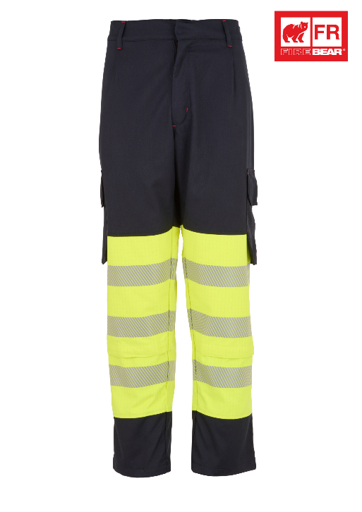
is in conformity with the provisions of PPE Regulation (EU) 2016/425 (Cat III) and satisfies the essential health and safety requirements set out in Annex II and the relevant harmonised standard(s):
EN ISO 13688:2013 + EN ISO 13688:2013/A1:2021
EN ISO 11611:2015 (A1) Class 1
EN ISO 11612:2015 A1 B1 C1 E1 F1
EN 1149-5:2018
EN 61482-2:2020 APC 2
EN 61482-1-2:2014
EN ISO 20471:2013 + EN ISO 20471:2013/A1:2016 Class 1

The PPE is identical to the model subject to the EU type examination certificate (Module B) referenced in certificate number

Cert No: 24/07305/00/0161
Issued by: 0161 Aitex, Carretera Banyeres, No 10, 03802, Alcoy, Spain.

The PPE is subject to the conformity to type assessment procedure based on quality assurance of the production process (Module C) as detailed in PPE Regulation (EU) 2016/425 as brought into UK Law and amended under surveillance of the approved body: Aitex, Carretea Banyeres, No 10, 03802, Alcoy, Spain. Notified Body No: 0161

Signed for and on behalf of Tower Supplies
Date: 01.04.25

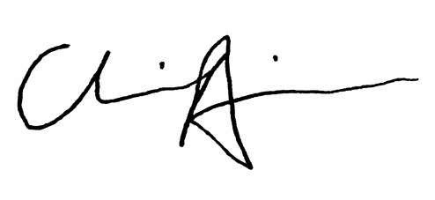
_____________________________
Charlie Aris
CEO

