
PERSONAL PROTECTIVE EQUIPMENT REGULATION (EU) 2016/425

This declaration of Conformity is issued under the sole responsibility of the manufacturer Tower Supplies, 3 Yarrow Road, Poole, Dorset, BH12 4TS declares that the following Personal Protective Equipment (PPE)

Model/Label: C21.FB2122F
Name: FireBear Female FR AS APC 2 Cargo Trouser - Navy

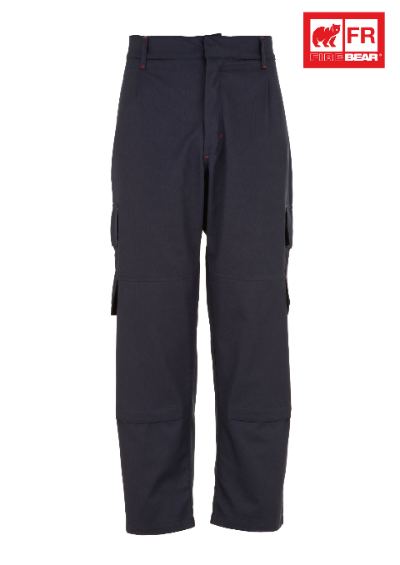
is in conformity with the provisions of PPE Regulation (EU) 2016/425 (Cat III) and satisfies the essential health and safety requirements set out in Annex II and the relevant harmonised standard(s):
EN ISO 11612:2015 A1 B1 C1
EN 1149-5:2018
EN 61482-2:2020 APC 2

The PPE is identical to the model subject to the EU type examination certificate (Module B) referenced in certificate number

Cert No: 523758
Issued by: 0338, BTTG, Manchester, M17 1EH

The PPE is subject to the conformity to type assessment procedure based on quality assurance of the production process (Module C) as detailed in PPE Regulation (EU) 2016/425 as brought into UK Law and amended under surveillance of the approved body: BTTG, Manchester, M17 1EH. Notified body number: 0338

Signed for and on behalf of Tower Supplies
Date: 01.04.25


_____________________________
Charlie Aris
CEO

