
PERSONAL PROTECTIVE EQUIPMENT REGULATION (EU) 2016/425

This declaration of Conformity is issued under the sole responsibility of the manufacturer Tower Supplies, 3 Yarrow Road, Poole, Dorset, BH12 4TS declares that the following Personal Protective Equipment (PPE)

Model/Label: C21.FB2122F
Name: FireBear Female FR AS HV APC 2 Cargo Trouser – Saturn Yellow/Navy
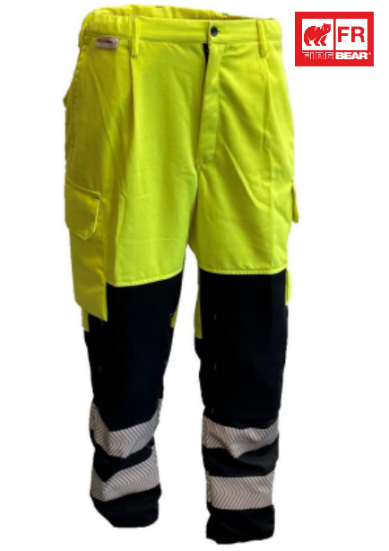

is in conformity with the provisions of PPE Regulation (EU) 2016/425 (Cat III) and satisfies the essential health and safety requirements set out in Annex II and the relevant harmonised standard(s):
EN ISO 11612:2015 A1 B1 C1
EN 1149-5:2018
EN 61482-2:2020 APC 2
EN ISO 20471:2013 Class 1

The PPE is identical to the model subject to the EU type examination certificate (Module B) referenced in certificate number

Cert No: 523758
Issued by: 0338 BTTG, Manchester, M17 1EH

The PPE is subject to the conformity to type assessment procedure based on quality assurance of the production process (Module C) as detailed in PPE Regulation (EU) 2016/425 as brought into UK Law and amended under surveillance of the approved body: BTTG, Manchester, M17 1EH. Notified body number: 0338

Signed for and on behalf of Tower Supplies
Date: 01.04.25


_____________________________
Charlie Aris
CEO

