
PERSONAL PROTECTIVE EQUIPMENT REGULATION (EU) 2016/425

This declaration of Conformity is issued under the sole responsibility of the manufacturer Tower Supplies, 3 Yarrow Road, Poole, Dorset, BH12 4TS declares that the following Personal Protective Equipment (PPE)

Model/Label: C21.FB216
Name: FireBear Male APC1 Cargo Trouser
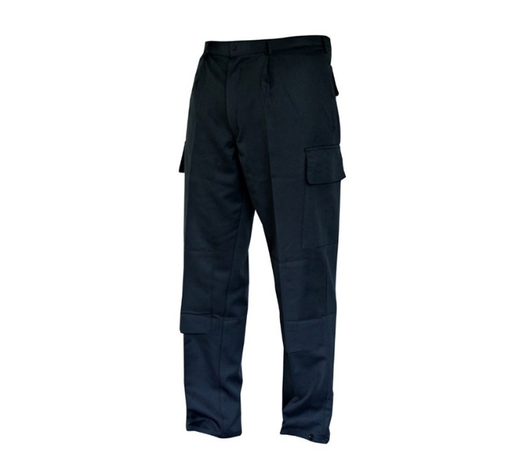

is in conformity with the provisions of PPE Regulation (EU) 2016/425 (Cat III) and satisfies the essential health and safety requirements set out in Annex II and the relevant harmonised standard(s):

The PPE is identical to the model subject to the EU type examination certificate (Module B) referenced in certificate number
EN ISO 13688:2013 + EN ISO 13688:2013/A1:2021
EN ISO 11612:2015 – A1 B1 C1 F1
EN 1149-5:2018
EN61482-2:2020 – APC1

Cert No: 25/08591/00/0161/B
Issued by: 0161 Aitex, Carretera Banyeres, No 10, 03802, Alcoy, Spain.

The PPE is subject to the conformity to type assessment procedure based on quality assurance of the production process (Module C) as detailed in PPE Regulation (EU) 2016/425 as brought into UK Law and amended under surveillance of the approved body: Aitex, Carretea Banyeres, No 10, 03802, Alcoy, Spain. Notified Body No: 0161

Signed for and on behalf of Tower Supplies
Date: 16/07/2025


_____________________________
Charlie Aris
CEO

