
PERSONAL PROTECTIVE EQUIPMENT REGULATION (EU) 2016/425

This declaration of Conformity is issued under the sole responsibility of the manufacturer Tower Supplies, 3 Yarrow Road, Poole, Dorset, BH12 4TS declares that the following Personal Protective Equipment (PPE)

Model/Label: C21.FB4272
Name: FireBear Wet Weather AS HV APC 2 Salopettes
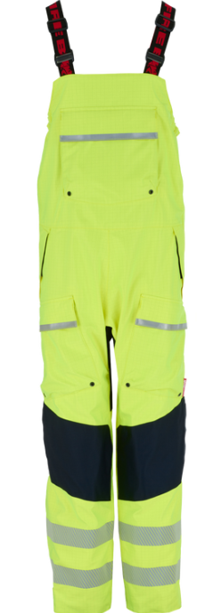
is in conformity with the provisions of PPE Regulation (EU) 2016/425 (Cat III) and satisfies the essential health and safety requirements set out in Annex II and the relevant harmonised standard(s):
EN 340:2003
EN ISO 13688:2013/A1:2021
EN ISO 11612:2015 A1+A2+B1 C1
EN ISO 11611:2015 A1+A2 Class 2
EN 343: 2019 3:4
EN 61482-2:2020 APC 2
EN 1149-5:2018
EN 13034:2005+ A1:2009 Type PB (6)
EN ISO 20471:2013 / A1:2016 Class 3

The PPE is identical to the model subject to the EU type examination certificate (Module B) referenced in certificate number

Cert No: 24/07482/00/0161
Issued by: 0161 Aitex, Carretera Banyeres, No 10, 03802, Alcoy, Spain.

The PPE is subject to the conformity to type assessment procedure based on quality assurance of the production process (Module C) as detailed in PPE Regulation (EU) 2016/425 as brought into UK Law and amended under surveillance of the approved body: Mirta – Kontrol D.O.O Javorinska 3, HR- 10042 Zagreb – Dubrava. Notified Body No. 2474

Signed for and on behalf of Tower Supplies
Date:

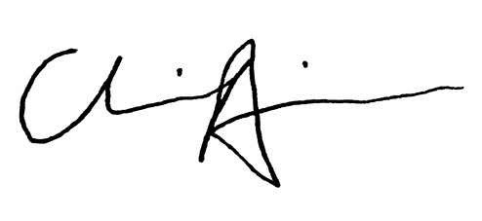
Charlie Aris
CEO

