This declaration of Conformity is issued under the sole responsibility of the manufacturer Tower Supplies, 3 Yarrow Road, Poole, Dorset, BH12 4TS declares that the following Personal Protective Equipment (PPE)
Model/Label: C21.FB4583
Name: FireBear Female FR Wet Weather AS HV APC 2 Trouser – Yellow
is in conformity with the provisions of PPE Regulation (EU) 2016/425 (Cat III) and satisfies the essential health and safety requirements set out in Annex II and the relevant harmonised standard(s):  EN ISO 13688:2013/A1:2021  EN ISO 11612:2015 A1 B1 C1 F1  EN 343: 2019 4:2  EN 61482-2:2020 APC 2  EN 1149-5:2018  EN ISO 20471:2013 / A1:2016 Class 2 | 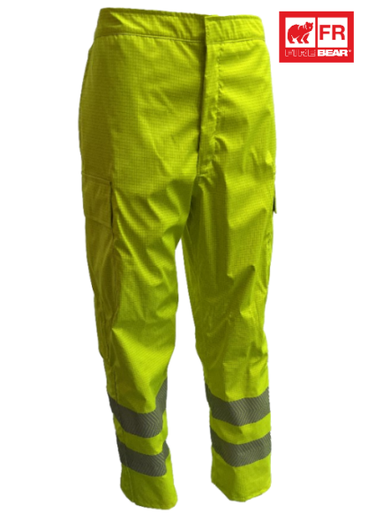
The PPE is identical to the model subject to the EU type examination certificate (Module B) referenced in certificate number
Cert No: SH00621
Issued by: 2995 – Shirley Technologies, Office 13 Unit 21 Clonshaugh Business and Technology Park, Dublin 17, Republic of Ireland
The PPE is subject to the conformity to type assessment procedure based on quality assurance of the production process (Module C) as detailed in PPE Regulation (EU) 2016/425 as brought into UK Law and amended under surveillance of the approved body: Shirley Technologies, Office 13 Unit 21 Clonshaugh Business and Technology Park, Dublin 17, Republic of Ireland. Notified Body No. 2995 | Signed for and on behalf of  Tower Supplies  Date: 01.10.25  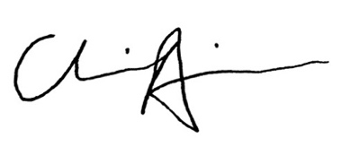  __________________________  Charlie Aris  CEO

