This declaration of Conformity is issued under the sole responsibility of the manufacturer Tower Supplies, 3 Yarrow Road, Poole, Dorset, BH12 4TS declares that the following Personal Protective Equipment (PPE)
Model/Label: C21.FB521
Name: FireBear FR AS APC1 Snood
is in conformity with the provisions of PPE Regulation (EU) 2016/425 (Cat III) and satisfies the essential health and safety requirements set out in Annex II and the relevant harmonised standard(s):  EN ISO 11612:2015 A1 B1 C1 F1  IEC 61482-2:2018  EN 61482-1-2:2014 APC 1  EN 1149-5:2018 | 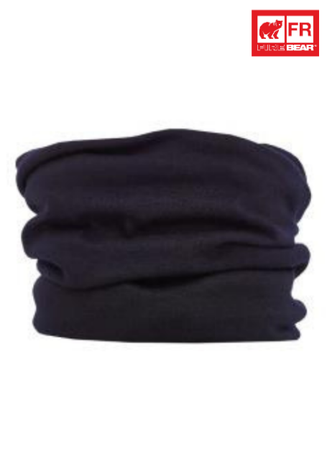
The PPE is identical to the model subject to the EU type examination certificate (Module B) referenced in certificate number
Cert No: 2777/18985-01/E01-01
Issued by: 2777 - Satra Technology Europe Limited. Bracetown Business Park, Clonee, D15YN2P, Republic of Ireland
The PPE is subject to the conformity to type assessment procedure based on quality assurance of the production process (Module C) as detailed in PPE Regulation (EU) 2016/425 as brought into UK Law and amended under surveillance of the approved body: Satra Technology Europe Limited. Bracetown Business Park, Clonee, D15YN2P, Republic of Ireland. Notified Body No. 2777 | Signed for and on behalf of  Tower Supplies  Date: 01.12.25  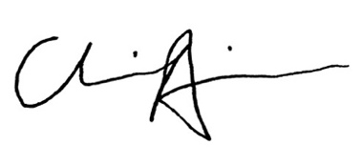  __________________________  Charlie Aris  CEO

