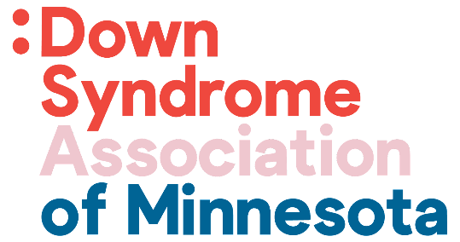

Transition to 18 Checklist

A Reference Guide to assist you in completing the process of changes that occur when your child is transitioning into Adulthood.

- Educational Planning and VRS
- Apply for state issued ID
- Males: Register for Selective Services
- Decide on Guardianship or Supported Decision Making
- Apply for SSI – Supplemental Security Income
- Apply for MA – Medical Assistance (County)
- Request a MnCHOICES Assessment
- Waiver Programs
- Additional Government Programs
- Transition Medical Providers
- Start Planning for Life After Transition Plus Program (Turning 22)

Each step is a stop on the journey that includes many details, please reach out if you have any questions or concerns - I can help you through the process.
Danyel Hinson
danyel@dsamn.org

